Part of: GROUP BY & HAVING :-To summarize E-Commerce data using SQL GROUP BY, HAVING, and aggregate functions to generate meaningful business insights.

Basic Counts

Task Description:
Count the number of orders placed for each product.

SQL Query:
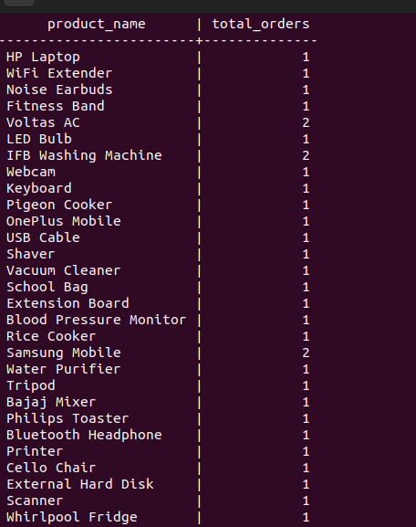
SELECT p.product_name, COUNT(oi.order_id) AS total_orders FROM products p INNER JOIN order_items oi ON p.product_id = oi.product_id GROUP BY p.product_name;

Explanation:This query groups order data by product name and counts how many times each product has been ordered.

Condition on Groups (HAVING)

Task Description:
Find products that have been ordered more than 5 times.

SQL Query:
SELECT p.product_name,COUNT(oi.order_id) AS total_orders FROM products p INNER JOIN order_items oi ON p.product_id = oi.product_id GROUP BY p.product_nameHAVING COUNT(oi.order_id) > 5;

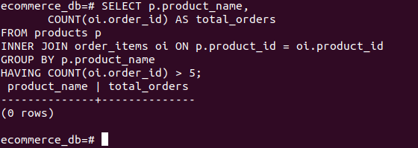

Explanation:
The HAVING clause filters grouped data and returns only those products with more than 5 orders.

Statistics (Average Calculation)

Task Description:
Calculate the average product price.

SQL Query:
SELECT AVG(price) AS average_product_price FROM products;
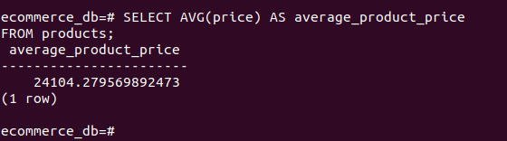

Explanation:
This query calculates the average price of all products, providing insight into overall pricing trends.

